Name: __________________________________________________________________ Period: ______
Notes
The Normal Distribution

Definition:
Standard Deviation:

Normal Distribution

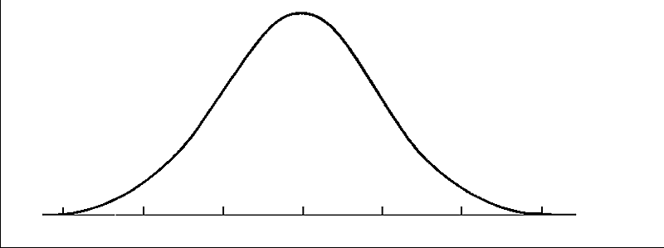

The Empirical Rule

Example: The heights of players in a basketball league are normally distributed with a mean of 6 feet 1 inch and a standard deviation of 2 inches.

EGG PRODUCTION The number of eggs laid per year by a particular breed of chicken is normally distributed with a mean of 225 and a standard deviation of 10 eggs.

MANUFACTURING The diameter of bolts produced by a manufacturing plant is normally distributed with a mean of 18 mm and a standard deviation of 0.2 mm.

