Skills Practice
Solving Inequalities

Solve each inequality. Then graph the solution set on a number line.

- $\frac{z}{-4}$ ≥ 2

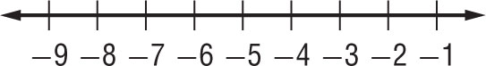
- 3a + 7 ≤ 16

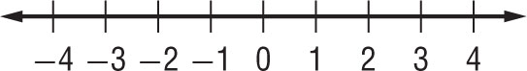

- 16 < 3q + 4

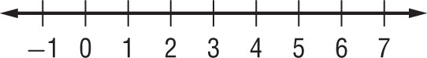
- 20 – 3n > 7n

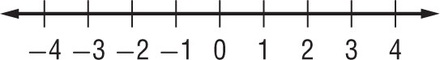

- 3x ≥ –9

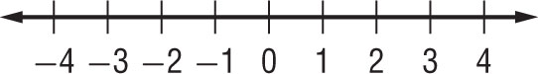
- 4b – 9 ≤ 7

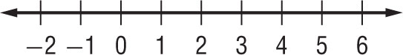

- 2z < –9 + 5z

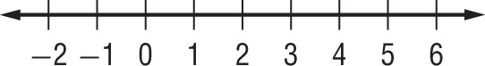
- 7f – 9 > 3f – 1

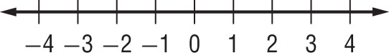

- –3k – 8 ≤ 5k

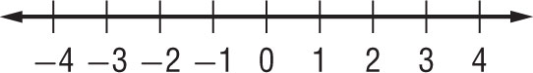
- 7t – (t – 4) ≤ 25

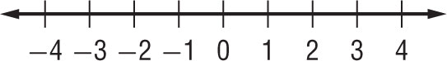

- 4x – 9 > 2x + 1

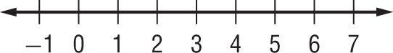
- 4(5x + 7) ≤ 13

