Study Guide and Intervention
Solving Inequalities

Example 1: Solve 2x + 4 > 36.
Graph the solution set on a number line.

Example 2: Solve 17 – 3w ≥ 35.
Graph the solution set on a number line.

Exercises

Solve each inequality. Then graph the solution set on a number line.

- 7(7a – 9) ≤ 84

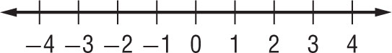
- 3(9z + 4) > 35z – 4

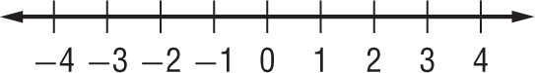
3. 5(12 – 3n) < 165

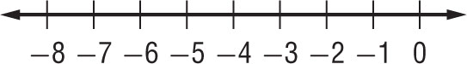

- 18 – 4k < 2(k + 21)

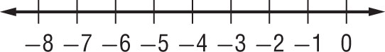

5. 4(b – 7) + 6 < 22

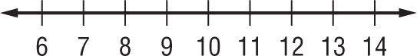

6. 2 + 3(m + 5) ≥ 4(m+ 3)

